**LIBRARY MANAGEMENT SYSTEM**

**Project report submitted in partial fulfillment of the Requirements for the Award of the Degree of**

**BACHELOR OF TECHNOLOGY**

**In**

**ELECTRICAL COMMUNICATION AND ENGINEERING**

**By**

**24KB1A04P4**

**24KB1A04T5**

**24KB1A04M7**

**24KB1A04D8**

**Under the Guidance of**

**Mr.SATHISH**



**ELECTRICAL COMMUNICATION AND ENGINEERING**

**NBKRIST**

**(AUTONOMOUS)**



**CERTIFICATE**

This is to certify that the project report entitled Library Management System being submitted by

**24KB1A04P4**

**24KB1A04T5**

**24KB1A04M7**

**24KB1A04D8**

in partial fulfillment for the award of the Degree of Bachelor of Technology in Electrical Communication and Engineering to the

Jawaharlal Nehru Technological University, Ananthapuram is a record of bona fied work carried out under my guidance and supervision.

**Mr.Sathish Dr. HARINADH REDDY**

**M.Tech, Ph.D**

**Designation**  **Head of the Department**

**DECLARATION**

I hereby declare that the dissertation entitled  **Library**

**Management System** submitted for the B.Tech Degree is my original work and the dissertation has not formed the basis for the award of any degree, association ship, fellow ship or any other similar titles.

24KB1A04P4

Place: 24KB1A04T5

Vidya Nagar 24KB1A04M7

24KB1A04D8

* Date: 07-05-25 **Acknowledgement**

**I would like to express my sincere gratitude to all those who supported me throughout the course of this project.**

**First and foremost, I am deeply thankful to MR.SATHISH, whose guidance, feedback, and support were invaluable in completing this work.**

**I also extend my appreciation to NBKRIST for providing the resources and environment necessary for the successful execution of the project.**

**Special thanks to my colleagues, friends, and family for their encouragement and moral support during this journey.**

**Lastly, I am grateful to all those who contributed, directly or indirectly, to the completion of this project.**

Abstract

A Library Management System (LMS) is a software application designed to manage and automate the operations of a library. It helps in maintaining records of books, tracking borrowed and returned items, managing member information, and streamlining administrative tasks. Traditional libraries often face challenges such as manual record-keeping, book misplacement, and time-consuming inventory management. An LMS addresses these issues by offering a centralized digital platform for efficient and accurate library operations. With features like book cataloging, user authentication, search functionality, and overdue notifications, an LMS improves accessibility, saves time, and enhances the overall user experience for both library staff and patrons.

**1.INTRODUCTION**

Managing a library manually is time-consuming, prone to errors, and inefficient, especially as the volume of books and users increases. Traditional methods often involve physical record-keeping, which can lead to misplacement of books, difficulty in tracking borrowed or overdue items, and challenges in maintaining accurate member information. Additionally, searching for books or managing inventory manually is slow and limits user accessibility. There is a need for an automated Library Management System that can streamline these processes, improve data accuracy, provide real-time information, and enhance the overall efficiency and

2. SCOPE

Automates daily library operations such as issuing, returning, and reserving books.

* Maintains records of books, members, and transactions efficiently.
* Allows librarians to add, update, or remove book and member details.
* Enables users to search for books by title, author, or subject.
* Tracks due dates and calculates fines for overdue books.
* Sends reminders/notifications for due or overdue books.
* Provides role-based access for admins, librarians, and members.
* Generates reports on book usage, inventory status, and member activity.
* Can be scaled to support large volumes of data and users.
* Future-ready for integration with barcode/RFID systems and online public access catalog (OPAC).

3.OBJECTIVE

The primary objective of the Library Management System is to automate and streamline the various operations of a library, reducing manual effort and enhancing efficiency. It aims to provide accurate and real-time access to information about books, members, and transactions. By simplifying the processes of book issuance, return, and catalog search, the system improves the overall user experience for both librarians and members. It also helps in monitoring overdue books and calculating fines, ensuring better control over library resources. Additionally, the system supports report generation for inventory and user activity, assisting in informed decision-making. Security and role-based access control are also key objectives, ensuring that only authorized users can perform specific tasks. Overall, the system is designed to support the growing needs of modern libraries and lay the groundwork for future digital enhancements.

4.CONTROL FLOW CHART

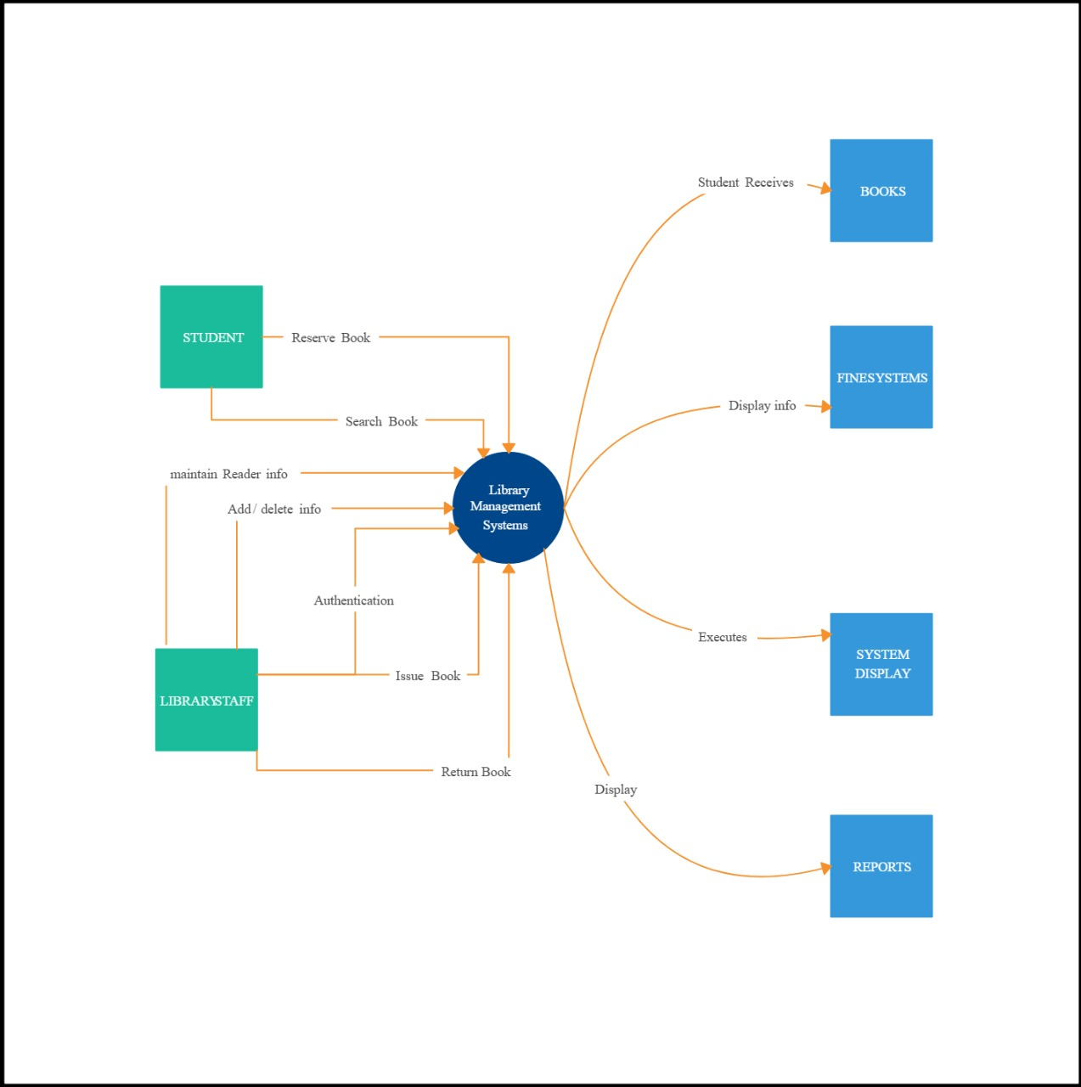

# 

5.Modules And Their Functionalities

Below are some of the points we have to cover in the synopsis report :

* Project Title
* Introduction of Project
* Problem Statement
* Proposed Solution
* Objective of the Project
* Scope of the Project
* Methodologies used
* ER Model
* Use case Diagram
* Dataflow Diagram
* Features of the project
* For Users
* For Admin
* Impact of the project
* Limitations of the project
* Future scope of the project

6.Code

#include <stdio.h>

#include <stdlib.h>

#include <string.h>

struct Book {

int id;

char title[100];

char author[100];

};

void addBook() {

struct Book b;

FILE *fp = fopen("library.dat", "ab");

if (!fp) {

printf("Unable to open file!\n");

return;

}

printf("Enter Book ID: ");

scanf("%d", &b.id);

getchar(); // consume newline

printf("Enter Book Title: ");

fgets(b.title, sizeof(b.title), stdin);

b.title[strcspn(b.title, "\n")] = 0; // remove newline

printf("Enter Book Author: ");

fgets(b.author, sizeof(b.author), stdin);

b.author[strcspn(b.author, "\n")] = 0;

fwrite(&b, sizeof(b), 1, fp);

fclose(fp);

printf("Book added successfully!\n");

}

void displayBooks() {

struct Book b;

FILE *fp = fopen("library.dat", "rb");

if (!fp) {

printf("No books found.\n");

return;

}

printf("\n%-10s %-30s %-30s\n", "Book ID", "Title", "Author");

while (fread(&b, sizeof(b), 1, fp)) {

printf("%-10d %-30s %-30s\n", b.id, b.title, b.author);

}

fclose(fp);

}

void searchBook() {

int id;

struct Book b;

FILE *fp = fopen("library.dat", "rb");

if (!fp) {

printf("No books found.\n");

return;

}

printf("Enter Book ID to search: ");

scanf("%d", &id);

int found = 0;

while (fread(&b, sizeof(b), 1, fp)) {

if (b.id == id) {

printf("Book found!\n");

printf("ID: %d\nTitle: %s\nAuthor: %s\n", b.id, b.title, b.author);

found = 1;

break;

}

}

if (!found)

printf("Book not found.\n");

fclose(fp);

}

void deleteBook() {

int id;

struct Book b;

FILE *fp = fopen("library.dat", "rb");

FILE *temp = fopen("temp.dat", "wb");

if (!fp || !temp) {

printf("File error.\n");

return;

}

printf("Enter Book ID to delete: ");

scanf("%d", &id);

int deleted = 0;

while (fread(&b, sizeof(b), 1, fp)) {

if (b.id != id) {

fwrite(&b, sizeof(b), 1, temp);

} else {

deleted = 1;

}

}

fclose(fp);

fclose(temp);

remove("library.dat");

rename("temp.dat", "library.dat");

if (deleted)

printf("Book deleted successfully.\n");

else

printf("Book ID not found.\n");

}

int main() {

int choice;

do {

printf("\nLibrary Management System\n");

printf("1. Add Book\n2. Display Books\n3. Search Book\n4. Delete Book\n5. Exit\n");

printf("Enter your choice: ");

scanf("%d", &choice);

getchar(); // flush newline

switch (choice) {

case 1: addBook(); break;

case 2: displayBooks(); break;

case 3: searchBook(); break;

case 4: deleteBook(); break;

case 5: printf("Exiting...\n"); break;

default: printf("Invalid choice.\n");

}

} while (choice != 5);

return 0;

}

7. Output Screens

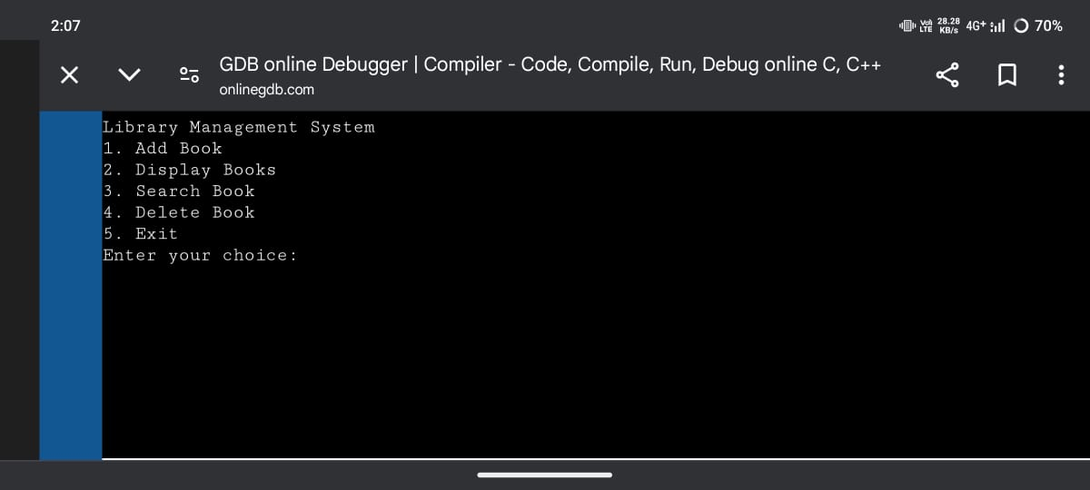

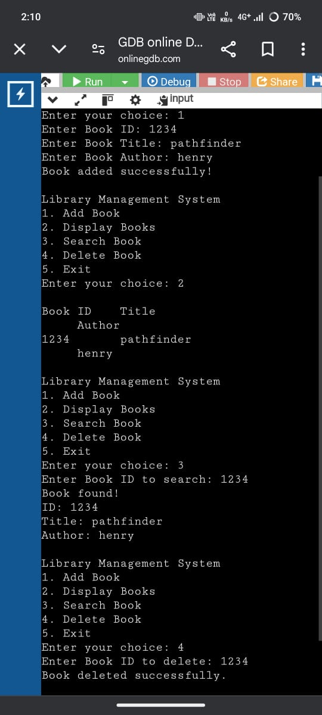

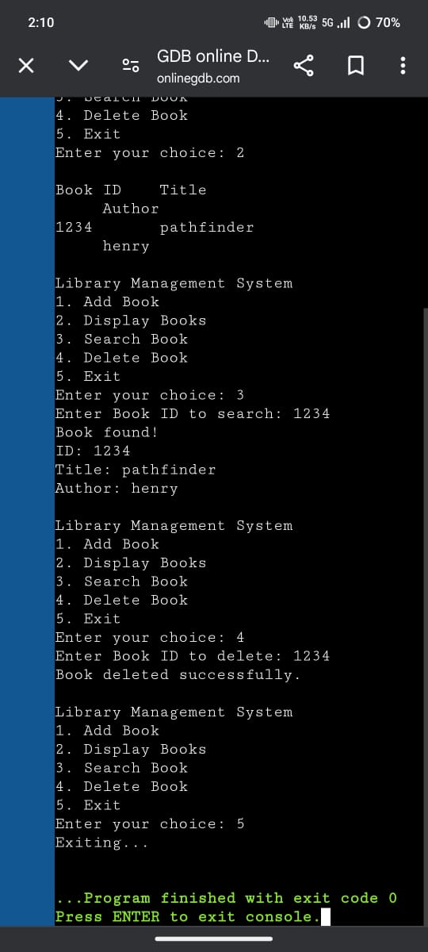  
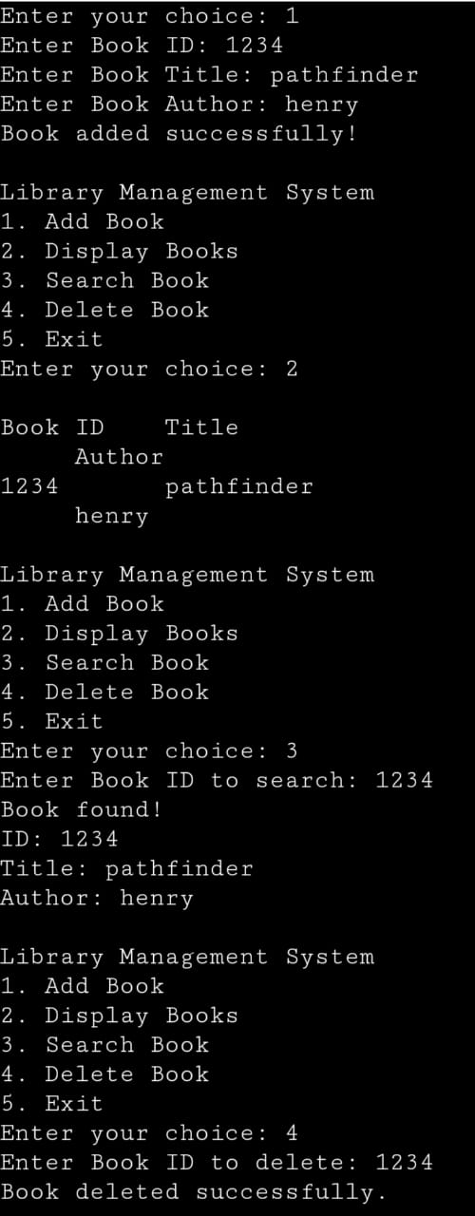

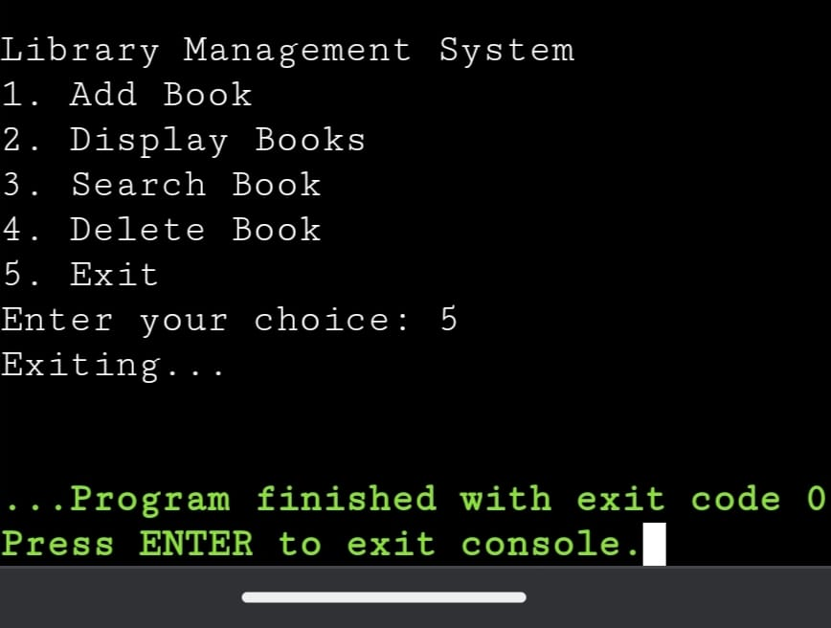8. Conclusion

The Library Management System (LMS) stands as a cornerstone in the modernization of libraries, serving as

a powerful tool to streamline operations, enhance user experiences, and facilitate access to a wealth of

resources. Despite its undeniable advantages, including efficient cataloging, circulation management, and

reporting capabilities, the LMS is not without its limitations.

Looking ahead, the future of LMS holds promise with the integration of emerging technologies like artificial

intelligence, blockchain, and virtual reality, paving the way for innovative solutions to further enhance library

services and adapt to evolving user expectations

In essence, while mindful of its limitations, the Library Management System remains a fundamental asset in

the preservation and dissemination of knowledge, empowering libraries to fulfill their mission as vital hubs

of learning and community engagement in an ever-changing digital landscape. Through continued innovation,

collaboration, and commitment to excellence, the LMS will continue to evolve, enriching the lives of patrons

and contributing to the advancement of society as a whole.